Table of Contents
Intelligent RPA for Accounts Payable Invoice Extraction 2
Recommended Enterprise Architecture & Technology Stack 2
Project Overview 2
1. Recommended Technology Stack 2
2. Best OCR & AI Recommendation 3
Final Recommended Choice: Azure Document Intelligence 3
Comparison 3
Why Azure Document Intelligence? 3
3. Recommended System Architecture 4
Core Services 4
3.1 Ingestion Service 4
Supported Sources 4
Technologies 4
3.2 Processing Service 4
Processing Steps 4
Technologies 4
3.3 Validation Service 5
Responsibilities 5
3.4 ERP Integration Service 5
Supported ERPs 5
Integration Modes 5
3.5 Human-in-the-Loop Dashboard 5
Features 5
Frontend Technologies 6
4. Recommended Database Design 6
Final Recommendation: PostgreSQL 6
5. High-Level Database Schema 6
Tenants Table 6
Users Table 7
Invoices Table 7
Invoice Fields Table 7
Line Items Table 7
Audit Logs Table 8
6. AI Extraction Pipeline 8
Step 1 — Invoice Ingestion 8
Step 2 — PDF Processing 8
Conversion 8
Preprocessing 8
Step 3 — OCR & AI Extraction 9
Step 4 — Confidence Scoring 9
Validation Rules 9
Routing Logic 9
7. Human-in-the-Loop (HITL) Workflow 9
Verification Interface 9
Left Panel 9
Right Panel 10
Active Learning 10
8. ERP Integration Strategy 10
API-First Integration 10
Workflow 10
9. RPA Fallback Strategy 11
Recommended Tool: Playwright 11
10. Security Architecture 11
Recommended Security Features 11
Authentication 11
Encryption 11
Audit Logging 11
11. Production Deployment Strategy 12
Containerization 12
Containers 12
Kubernetes Deployment 12
12. Monitoring & Observability 12
Monitoring Stack 12
13. Scalability Strategy 13
Scalability Techniques 13
14. API Design (OpenAPI Style) 13
Upload Invoice 13
Get Invoice Status 13
Review Queue 13
Submit Corrections 13
ERP Submission 13
15. Best Practices to Avoid AI Hallucinations 14
Rule-Based Validation 14
Arithmetic Reconciliation 14
Confidence Thresholds 14
Source Grounding 14
Final Recommended Architecture Summary 15
Best Overall Stack 15
Backend 15
Frontend 15
OCR 15
AI Evolution 15
Infrastructure 15
Monitoring 15
RPA 15
Conclusion 15

Intelligent RPA for Accounts Payable Invoice Extraction

Project Overview
The proposed system is an AI-powered Intelligent RPA platform designed to automate the complete Accounts Payable (AP) invoice processing workflow. The platform will receive invoices from multiple sources, extract financial data using OCR and AI models, validate extracted information using confidence scoring, and automatically enter verified data into ERP systems with minimal human intervention.
The architecture is designed as a scalable B2B SaaS platform capable of handling thousands of invoices daily while maintaining security, auditability, and high extraction accuracy.

1. Recommended Technology Stack
After evaluating multiple enterprise technologies, the following stack is recommended for the final implementation.
Layer | Recommended Technology | Reason
Backend API | FastAPI | High-performance async APIs, excellent AI integration
Frontend | ReactJS + TypeScript | Scalable enterprise UI development
OCR Engine | Azure Document Intelligence | Best invoice extraction accuracy
AI Model | LayoutLMv3 (Future Fine-Tuning) | Spatial-aware document understanding
Database | PostgreSQL | Enterprise-grade relational database
Cache & Queue | Redis + Celery | Asynchronous processing and task queues
File Storage | AWS S3 / Cloudflare R2 | Scalable object storage
Authentication | OAuth2 + JWT | Secure enterprise authentication
Containerization | Docker | Portable deployments
Orchestration | Kubernetes | High scalability and fault tolerance
Monitoring | Prometheus + Grafana | System monitoring and metrics
Logging | ELK Stack | Centralized logging and debugging
RPA Automation | Playwright | Modern browser automation framework

2. Best OCR & AI Recommendation

Final Recommended Choice: Azure Document Intelligence
After comparing multiple OCR solutions, Azure Document Intelligence is the best option for this project.

Comparison
Feature | AWS Textract | Azure Document Intelligence | Custom LayoutLM
Invoice Accuracy | High | Very High | Depends on training
Table Extraction | Good | Excellent | Excellent
Setup Complexity | Low | Low | Very High
Training Required | No | No | Yes
Scalability | High | High | Medium
Maintenance | Low | Low | High
Cost Efficiency | Medium | Medium | High after training

Why Azure Document Intelligence?
The system requires highly accurate invoice and table extraction with minimal development complexity. Azure Document Intelligence provides:
- Excellent invoice field recognition
- Strong line-item extraction
- Built-in table understanding
- Multi-language support
- Reduced training requirements
- Fast enterprise deployment
For future improvements, a custom LayoutLMv3 model can be trained using correction data gathered from the Human-in-the-Loop dashboard.

3. Recommended System Architecture
The system will follow a microservices-based architecture to ensure scalability, maintainability, and independent deployment of components.

Core Services

3.1 Ingestion Service
Responsible for collecting invoices from multiple channels.

Supported Sources
- Email attachments (IMAP)
- SFTP uploads
- Manual uploads
- API uploads

Technologies
- FastAPI
- Redis Queue
- Celery Workers

3.2 Processing Service
Handles OCR, preprocessing, and AI extraction.

Processing Steps
- PDF validation
- PDF-to-image conversion
- Image preprocessing
- OCR processing
- Field extraction
- Confidence scoring
- Database storage

Technologies
- OpenCV
- pdf2image
- Azure Document Intelligence
- PyTorch (future AI training)

3.3 Validation Service
Evaluates extraction quality using confidence scoring.

Responsibilities
- Arithmetic validation
- Duplicate invoice detection
- Vendor validation
- Low-confidence routing

3.4 ERP Integration Service
Responsible for pushing extracted invoices into ERP systems.

Supported ERPs
- Odoo
- QuickBooks
- SAP
- Oracle NetSuite

Integration Modes
- REST APIs
- OAuth2 APIs
- RPA browser automation fallback

3.5 Human-in-the-Loop Dashboard
Allows users to verify and correct extracted invoice data.

Features
- Side-by-side PDF viewer
- Editable extracted fields
- Bounding-box highlights
- Correction history
- Approval workflows

Frontend Technologies
- ReactJS
- TypeScript
- PDF.js
- TailwindCSS

4. Recommended Database Design

Final Recommendation: PostgreSQL
PostgreSQL is the best choice because the system requires:
- Multi-tenant architecture
- Complex financial relationships
- Audit trails
- Transaction consistency
- Structured invoice metadata
Firebase is not recommended because financial systems require strong relational consistency and auditability.

5. High-Level Database Schema

Tenants Table
CREATE TABLE tenants (
id UUID PRIMARY KEY,
company_name VARCHAR(255),
plan_type VARCHAR(50),
created_at TIMESTAMP
);

Users Table
CREATE TABLE users (
id UUID PRIMARY KEY,
tenant_id UUID REFERENCES tenants(id),
name VARCHAR(255),
email VARCHAR(255),
role VARCHAR(50)
);

Invoices Table
CREATE TABLE invoices (
id UUID PRIMARY KEY,
tenant_id UUID REFERENCES tenants(id),
vendor_name VARCHAR(255),
invoice_number VARCHAR(255),
invoice_date DATE,
total_amount DECIMAL,
confidence_score FLOAT,
status VARCHAR(50),
pdf_url TEXT,
created_at TIMESTAMP
);

Invoice Fields Table
CREATE TABLE invoice_fields (
id UUID PRIMARY KEY,
invoice_id UUID REFERENCES invoices(id),
field_name VARCHAR(100),
extracted_value TEXT,
confidence FLOAT,
bbox JSONB
);

Line Items Table
CREATE TABLE line_items (
id UUID PRIMARY KEY,
invoice_id UUID REFERENCES invoices(id),
description TEXT,
quantity FLOAT,
unit_price FLOAT,
amount FLOAT
);

Audit Logs Table
CREATE TABLE audit_logs (
id UUID PRIMARY KEY,
invoice_id UUID,
action VARCHAR(255),
performed_by UUID,
old_value JSONB,
new_value JSONB,
created_at TIMESTAMP
);

6. AI Extraction Pipeline

Step 1 — Invoice Ingestion
Invoices are received through:
- Email attachments
- SFTP folders
- API uploads
- Manual uploads

Step 2 — PDF Processing

Conversion
PDF pages are converted into high-resolution images using:
pdf2image

Preprocessing
OpenCV is used for:
- Noise removal
- Deskewing
- Contrast enhancement
- Orientation correction

Step 3 — OCR & AI Extraction
Azure Document Intelligence extracts:
- Invoice number
- Vendor name
- Date
- Tax
- Total amount
- Purchase order number
- Line items

Step 4 — Confidence Scoring
Each extracted field receives a confidence score.

Validation Rules
- Date format validation
- Currency validation
- Arithmetic verification
- Vendor matching
- Duplicate invoice detection

Routing Logic
Confidence | Action
>95% | Auto-post to ERP
80–95% | Soft review
<80% | Manual verification

7. Human-in-the-Loop (HITL) Workflow
The HITL dashboard is essential for enterprise reliability.

Verification Interface

Left Panel
- Original invoice PDF
- Highlighted extraction regions

Right Panel
Editable extracted fields:
- Invoice number
- Vendor
- Tax
- Total
- Line items

Active Learning
User corrections are stored and later used to fine-tune the AI model.
This enables:
- Vendor-specific learning
- Reduced future errors
- Improved extraction accuracy over time

8. ERP Integration Strategy

API-First Integration
Primary integrations should use REST APIs whenever available.

Workflow
Extract Invoice
↓
Validate Data
↓
Map ERP Fields
↓
Send API Request
↓
Receive Confirmation

9. RPA Fallback Strategy
Some legacy ERP systems do not provide APIs.
In such cases, the system will use browser automation.

Recommended Tool: Playwright
Why Playwright?
- Faster than Selenium
- More reliable
- Better modern browser support
- Strong automation stability

10. Security Architecture
Because invoices contain sensitive financial data, enterprise-grade security is required.

Recommended Security Features

Authentication
- OAuth2
- JWT tokens
- Role-Based Access Control (RBAC)

Encryption
- AES-256 at rest
- TLS 1.3 in transit

Audit Logging
Every action must be recorded:
- User edits
- ERP submissions
- Approval actions
- AI corrections

11. Production Deployment Strategy

Containerization
Use Docker containers for all services.

Containers
- API Service
- Worker Service
- Frontend
- Redis
- PostgreSQL

Kubernetes Deployment
Kubernetes enables:
- Auto-scaling
- Load balancing
- Fault tolerance
- Rolling updates

12. Monitoring & Observability

Monitoring Stack
Purpose | Tool
Metrics | Prometheus
Visualization | Grafana
Logs | ELK Stack
Error Tracking | Sentry

13. Scalability Strategy
The architecture is designed to process more than 10,000 invoices per day.

Scalability Techniques
- Distributed Celery workers
- Redis queues
- Kubernetes autoscaling
- Parallel OCR processing
- Vendor-template caching

14. API Design (OpenAPI Style)

Upload Invoice
POST /api/v1/invoices/upload

Get Invoice Status
GET /api/v1/invoices/{id}

Review Queue
GET /api/v1/review/pending

Submit Corrections
POST /api/v1/review/{id}/correct

ERP Submission
POST /api/v1/erp/post/{id}

15. Best Practices to Avoid AI Hallucinations
Financial systems cannot rely entirely on AI predictions.
The following safeguards are mandatory.

Rule-Based Validation
Validate:
- Currency formats
- Dates
- Invoice IDs
- Tax calculations

Arithmetic Reconciliation
Verify:
Subtotal + Tax - Discount = Total

Confidence Thresholds
Low-confidence predictions must always go to manual review.

Source Grounding
Every extracted field must store:
- Bounding box
- OCR source text
- Page number
This prevents fabricated values.

Final Recommended Architecture Summary

Best Overall Stack

Backend
- FastAPI
- Celery
- Redis
- PostgreSQL

Frontend
- ReactJS + TypeScript

OCR
- Azure Document Intelligence

AI Evolution
- LayoutLMv3 fine-tuning

Infrastructure
- Docker
- Kubernetes

Monitoring
- Prometheus + Grafana + ELK

RPA
- Playwright

Conclusion
The proposed architecture provides a scalable, enterprise-grade Intelligent RPA solution for automated invoice extraction and ERP integration. The system combines OCR, AI-powered document understanding, human validation, and ERP automation into a unified SaaS-ready platform.
The recommended technology stack prioritizes:
- High extraction accuracy
- Enterprise scalability
- Security and auditability
- Human oversight
- Continuous AI improvement
- ERP compatibility
- Production readiness
This architecture is suitable for both MVP deployment and long-term enterprise expansion.
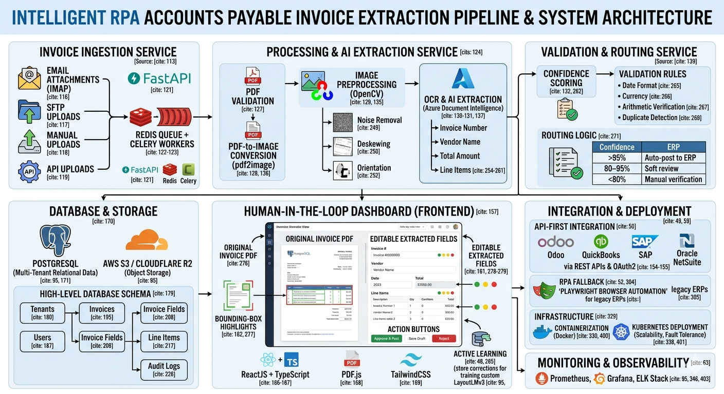
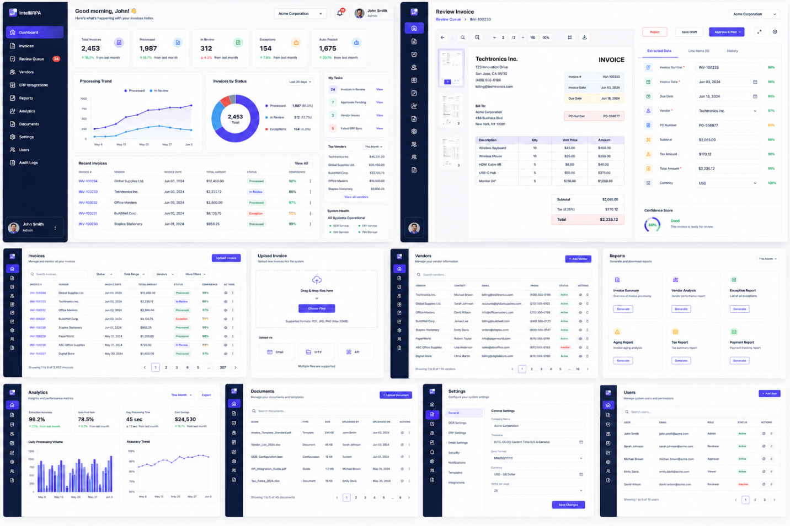

User PDF Upload
↓
FastAPI /upload endpoint
↓
PDF disk pe save (backend/uploads/)
Invoice Firestore mein create (status: "pending")
Audit log: "invoice_uploaded"
↓
Background Task shuru hota hai (async — user wait nahi karta)
↓
┌─────────────────────────────────────┐
│ AI Extraction Service │
│ Azure key hai? │
│ YES → Azure Document Intelligence │
│ NO → Mock extraction (demo data) │
│ Output: │
│ • vendor_name, invoice_number │
│ • total, subtotal, tax, discount │
│ • line items │
│ • confidence score per field │
└─────────────────────────────────────┘
↓
Validation Engine
- Arithmetic check: Subtotal + Tax - Discount = Total?
- Required fields check
- Date format check
↓
Confidence Routing:
- ≥ 95% → status: "approved" (auto, no human needed)
- 80-95% → status: "review" (soft review)
- < 80% → status: "review" (manual review, flagged)
↓
Firestore update: invoice + fields + line_items + audit_log

